FOR IMMEDIATE RELEASE

Mario Casabona Named 2014 Immigrant Entrepreneur of the Year
TechLaunch Founder Receives Top Prize in Ceremony hosted by Fairleigh Dickinson University

Montclair, New Jersey, December 10, 2014: TechLaunch Founder and Angel Investor, Mario Casabona was honored last evening as the 2014 Immigrant Entrepreneur of the Year in a special ceremony held at the mansion on the Florham Park campus. This was the second annual ceremony for the NJ Immigrant Entrepreneur Awards, a coalition of county and bi-national chambers of commerce, business and advocacy groups who work together to build awareness of the importance of the immigrant population to New Jersey’s economy and to the national economy as a whole.
Commenting on the accolade, Mr. Casabona said, "This award marks a personal as well as professional milestone, and one that I only wish my Sicilian parents were alive to witness. As proud as I've been of other achievements in my life, this recognition really speaks to the grateful immigrant in me who was not only welcomed to this great country but presented with all the resources and opportunities that - together with lots of hard work - enabled me to become whoever and whatever I desired."

Mario Casabona arrived in the United States from Italy at the age of five, the only child of his parents, Angelo (a barber) and Erminia (a seamstress) who raised their son with a strong work ethic and a grounded sense of confidence in his future as an American citizen. He became an electrical engineer and spent his entire career in NJ, creating his own defense technologies company, Electro-Radiation Inc. which, 22 years later was sold to Honeywell International in 2004. Not content to retire from the business landscape, Mario formed Casabona Ventures to invest in fledgling startups, and then became the Chairman of Jumpstart New Jersey Angel Network for four years before creating TechLaunch, NJ’s premier technology accelerator. In three programs, TechLaunch has launched 26 technology focused companies into the marketplace.
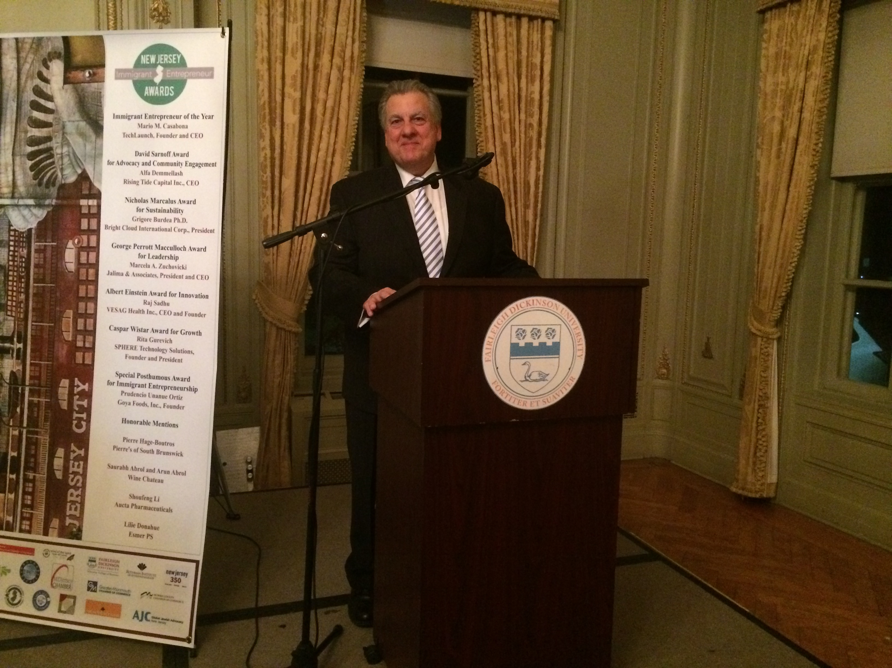

The NJ Immigrant Entrepreneur Awards were created to honor current first-generation immigrant business leaders whose lives and work have had a positive imprint on New Jersey communities. Historically, New Jersey’s immigrant entrepreneurs were responsible for the invention of the transistor, the submarine, Vitamin C, game theory, the chemical synthesis of penicillin, and instant coffee, just to name a handful. And iconic companies like Lipton Tea, Welch’s Grape Juice, Ballantine beer, and Colgate-Palmolive were founded by immigrant entrepreneurs who chose New Jersey for their homes and places of business. This year’s NJIEA winners come from South America, Africa, Europe and Asia. They hail from 10 countries, including Italy, China, Ethiopia, India, Lebanon, Mexico, Poland, Romania, Russia and Spain. They represent small family businesses as well as large corporations, ranging from high-tech firms to professional service providers, from manufacturing operations to food and financial institutions. Combined, the nominees employ thousands of people and do millions of dollars in sales.

About TechLaunch:
Formed in collaboration with the NJ Economic Development Authority (EDA) (njeda.com) and NJ Angel investors, TechLaunch, an investor led Technology Accelerator, was created in 2012 to drive the commercialization of emerging technology created by aspiring entrepreneurs. Since then it has launched 26 technology focused companies. TechLaunch provides a select group of emerging technology ventures with seed funding, access to over 130 qualified mentors, business training, co-working space, key business services and exposure to qualified investors, through a proven 16-week business boot camp program. The program culminates in Demo Day with Investor pitches and demonstrations of the developed products. To learn more please visit TechLaunch. Any media inquiries should be directed to Norma@TechLaunch.com.

About NJIEA:

The second annual NJIEA awards are coordinated by a broad-based coalition of New Jersey chambers, associations and organizations including: AJC New Jersey, Asian Indian Chamber of Commerce of New Jersey, Diversity Dynamics, Einstein’s Alley, the Greater Monmouth Chamber of Commerce, the Intersect Fund, the MIDJersey Chamber of Commerce, the Morris County Chamber of Commerce, the New Jersey Chinese-American Chamber of Commerce, the New Jersey Main Street Alliance, the New Jersey Historical Commission, the Rothman Institute of Entrepreneurship at Fairleigh Dickinson University, the Statewide Hispanic Chambers of Commerce of New Jersey, the United Hispanic Chambers of Commerce of New Jersey, Welcome.us, and Wind of the Spirit. More information about the NJ Immigrant Entrepreneur Awards can be found at http://njieawards.org/wp/about/.

# # #

